**Team Conductors**

**Assignments – 7**

**Barath Dharshan – CS23I1005**

**Bhadresh – CS23I1014**

**Aditya Lokesh – CS23I1029**

**Harith – CS23I1027**

**Prasanna Kumar M – CS23B1011**

1. **Expected Behaviour and Structure of our product in the graphical form.**

1)Every native and non-native speaker should know/be able to understand:

1. Bus stop name
2. Bus number
3. Bus route
4. Bus fare
5. Basic etiquettes(Don’t litter, Give appropriate change, etc…)
6. Bus schedules
7. Seating arrangements(separation of genders, place for old/PWD people)

2)Modern Transaction Methods(UPI)/QR:

1. Sorting & Dispensing denominations (Solves conductor’s problems, for non-mobile holders ex: school students)
2. Pre-booking using a QR code(For mobile holders, the conductor would check validity)

3)Visual Route Maps with Color Coding:

1. Map each location to a number and make it universal.
2. Each bus would contain a display containing these numbers.(When the location is reached the number corresponding to it will light up)
3. The colour of the number will change according to the proximity of the destination.

4)Audio Announcement System:

1. Mainly aimed at colour-blind people/blind people.
2. Announcements will be made in regional + 2 of the most commonly used languages(English and Hindi).
3. The status of the arrival at the stop will be announced periodically.
4. An understandable accent would be used

5)Mobile App with Language Support

1. Should be available in multiple Indian languages.
2. Should contain information on routes, fares, seat availability, bus stops etc..
3. Support for pre-booking
4. Help convey information (for example, to the conductor - Type out what you want in the app, it should translate to the language of the conductor. Generic things can be made available already)

2)**Key Functions in our system:**

| KEY FUNCTIONS(REQUIREMENTS) | TO FULFILL |
| --- | --- |
| Multi-lingual Support for Passengers | Linguistic Barrier |
| Modern Transaction Methods(UPI)/QR | Denomination |
| Visual Route Maps with Color Coding | Looking for Signage Clarity |
| Audio Announcement System | People who have trouble in reading |
| Feed-back  Mechanism for Non-Native Speakers | Help in improving services for demographic |
| Mobile App with Language Support | Include chat features that answers frequently asked questions |
| Digital Translation Tool | Only for conductors, tool that translate most common phrases |
| Pictographs | Universal icons to indicate most common services ( understand regardless of language) |
| Color Coded System | Make Fare understanding/Zones/Stops better |
| Frequency Chart in Bus Stops | Helps people in managing time better |

1. **ISM CONSTRUCTION FOR OUR PRODUCT**

**STEP 1 :REQUIREMENT MATRIX A :**

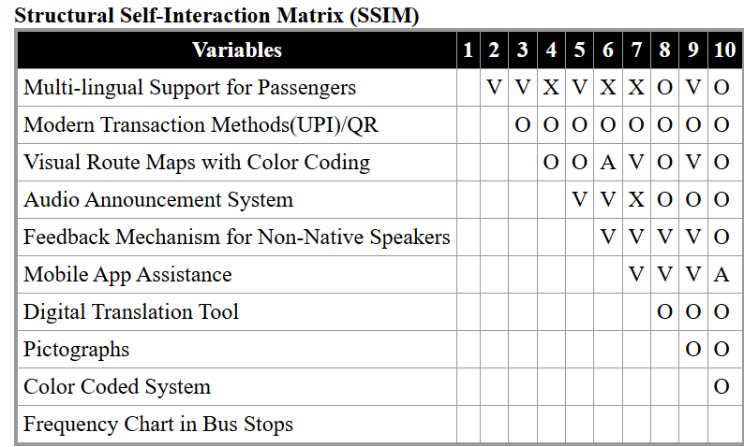

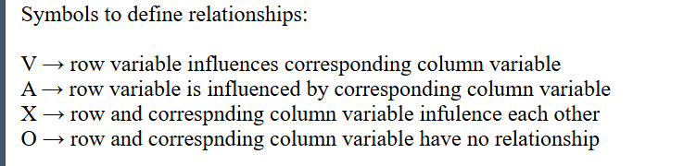

**STEP 2 : REPLACE WITH 0 AND 1 ON REQUIREMENT MATRIX TO GET REACHABILITY MATRIX : (A+I)**

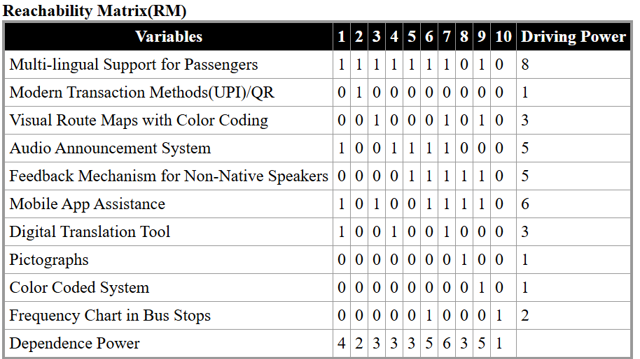

WHERE,

NO OF OUTDEGREE : DRIVING POWER

NO OF INDEGREE : DEPENDENCE POWER

INFERENCE:

Multilingual support for passengers received the highest out-degree , which seems to be the powerful driving factor

**STEP 3 :MULTIPLY (A+I) itself until reaching a saturation point to get (R):FINAL REACHABILTY MATRIX**

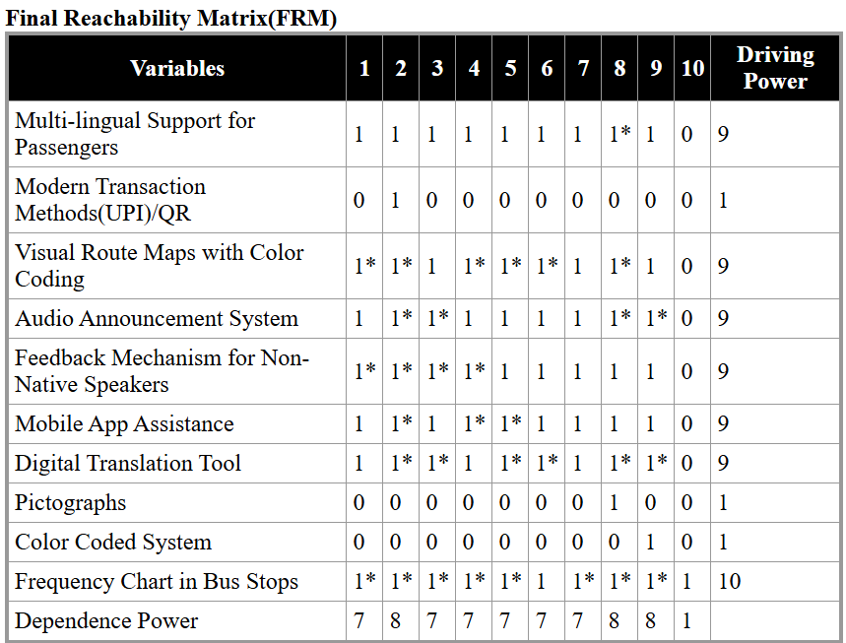

**STEP 4 :OBTAIN LEVEL PARTITIONING FROM REACHABILITY MATRIX**

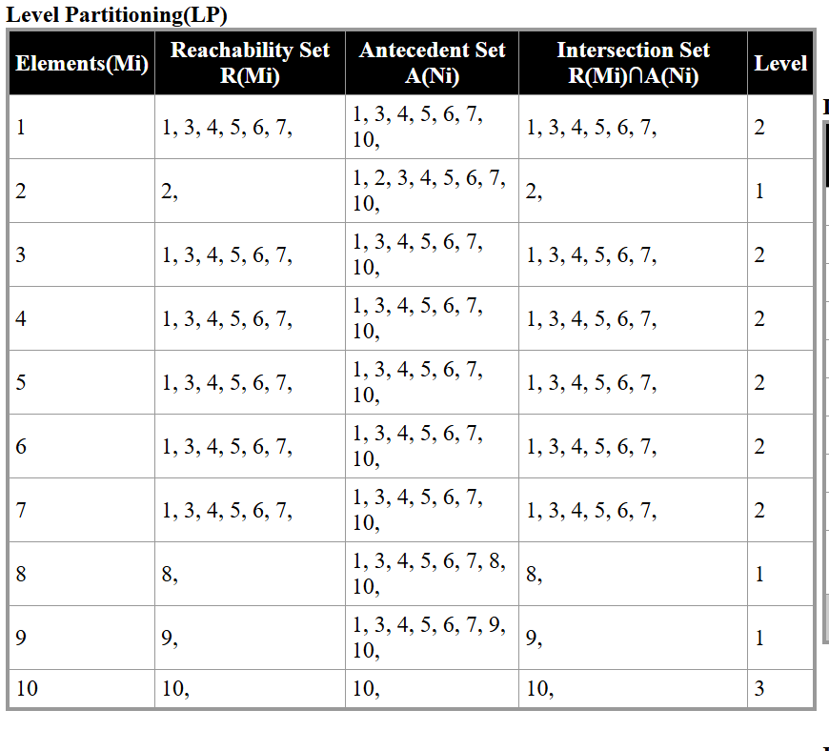

**THIS WAS THE FINAL GRAPH CONSTRUCTED USING THE LEVEL PARTITIONING**

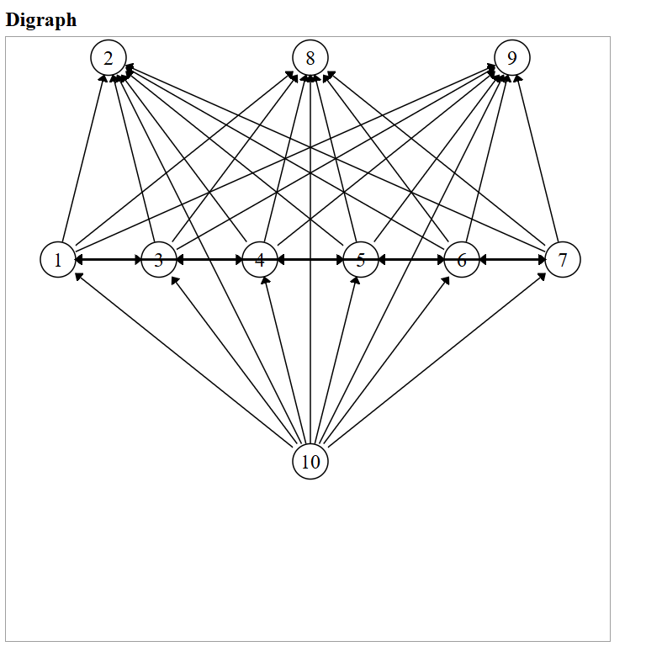

**CONCLUSION:**

The findings suggest that addressing foundational challenges, such as improving multilingual communication tools or training staff in effective customer interactions, could significantly enhance passenger experiences. The structured model also aids in prioritizing solutions, focusing on high-leverage areas to create impact, sustainable improvements in public transportation systems.

This ISM analysis provides a clear roadway for stakeholders to tackle these issues systematically, paving the way for an inclusive and efficient transit environment.